21.08 (b) RE-EVALUATION SALARY EXAMPLES:

FLOOR OF NEW SALARY GRADE:
SCENARIO: The successful candidate’s current salary is below the floor of new position’s salary grade.
PROCESS:
- Open the Salary Admin Manager Excel Sheet and click on the “Internal Salary Placement 21.08” tab to determine the appropriate salary placement based on the position’s new salary grade (SG) and the employee’s current salary.
- Enter the employee’s current salary into the yellow highlighted cell as seen in the image below and select the new position’s salary grade using the drop-down feature.
- Result: The staff member’s current salary plus 10% is lower than the floor of the new SG level, the salary placement should be the floor highlighted in green below:
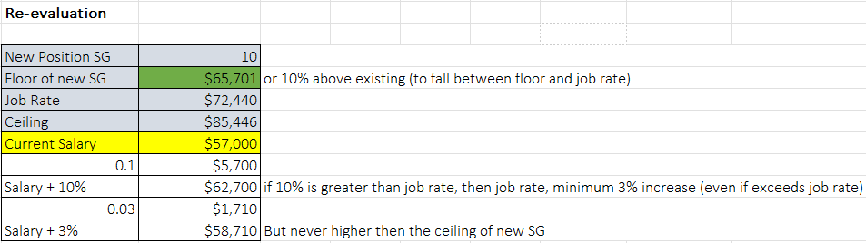

JOB RATE OF NEW SALARY GRADE:
SCENARIO: The successful candidate’s current salary is below the job rate of the new position’s salary grade.
PROCESS:
- Open the Salary Admin Manager Excel Sheet and click on the “Internal Salary Placement 21.08” tab to determine the appropriate salary placement based on the position’s new salary grade (SG) and the employee’s current salary.
- Enter the employee’s current salary into the yellow highlighted cell as seen in the image below and select the new position’s salary grade using the drop-down feature.
- Result: The staff member’s current salary plus 10% puts the salary above the job rate of the new SG level and a 3% increase is less than the job rate, the salary placement should be the job rate highlighted in green below:
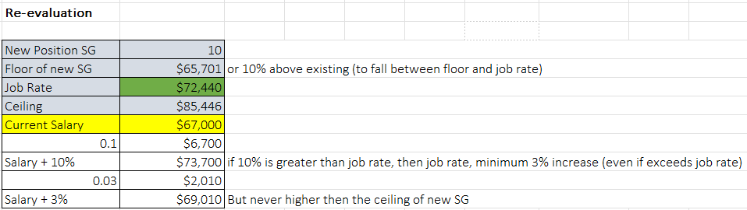

CURRENT SALARY + 3%:
SCENARIO: The successful candidate’s current salary is above or near the job rate of the new position’s salary grade.
PROCESS:
- Open the Salary Admin Manager Excel Sheet and click on the “Internal Salary Placement 21.08” tab to determine the appropriate salary placement based on the position’s new salary grade (SG) and the employee’s current salary.
- Enter the employee’s current salary into the yellow highlighted cell as seen in the image below and select the new position’s salary grade using the drop-down feature.
- Result: The staff member’s current salary plus 10% brings the salary above the job rate of the new SG level, the job rate is less than the minimum 3% increase, the salary placement should be the current salary + 3% highlighted in green below:
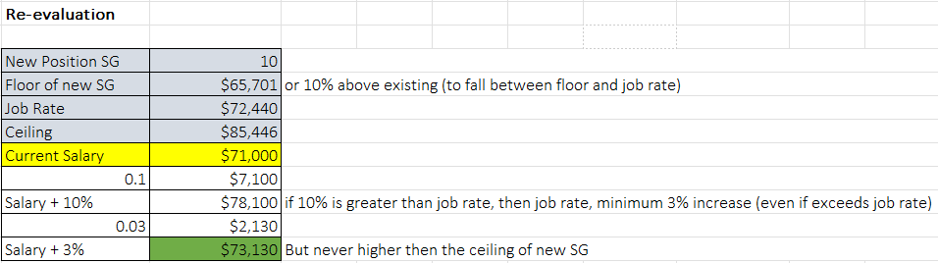

CURRENT SALARY + 10%:
SCENARIO: The successful candidate’s current salary is below the job rate of the new position’s salary grade.
PROCESS:
- Open the Salary Admin Manager Excel Sheet and click on the “Internal Salary Placement 21.08” tab to determine the appropriate salary placement based on the position’s new salary grade (SG) and the employee’s current salary.
- Enter the employee’s current salary into the yellow highlighted cell as seen in the image below and select the new position’s salary grade using the drop-down feature.
- Result: The staff member’s current salary plus 10% is below the job rate of the new SG level. The salary placement should be the current salary + 10% highlighted in green below:

